In this tutorial you will need to reference the first page and initialize a NodeJS project.

**How to use ExpressJS:**

1. 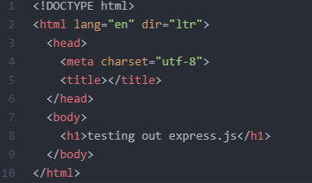If you referenced the first page of the notebook, along with the “app.js” you’ve created, add in an “index.html”.
2. In the html file, type in HT and hit tab, you may simply add in a header like this:
3. You need to install expressJS with either a batch file or CMD Prompt. You need to run one of the following commands: “npm i express” or “npm install express”.
4. 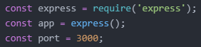To import the expressJS module and create a port, use the following lines of code:
5. 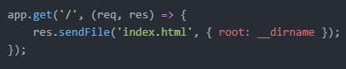Use “app.use(express.static('public'));”, this command tells Express to use middleware, it serves static assets and specifies where they are to be served.
6. Next, use “get()”, it will request data and send the “index.html” file.
7. Use “listen()” to create a listen server with ExpressJS.
8. Now all you have to do is run your “app.js” file – if you have forgotten how to do so, reference the other pages.

